

INTRODUCTION   
Fuel theft is a major issue that has been troubling the transportation and logistics industry, particularly in parts of the world where fuel is in high demand but there is not enough security apparatus in place. Beyond financial losses, unauthorized fuel siphoning can cause damage to the vehicle’s fuel system and raise operational risks. To overcome this issue, this project provides a low-cost and efficient solution to prevent theft of fuel using an ESP-32 module microcontroller and ultrasonic sensors. It continuously monitoring the fuel tank.

OBJECTIVES

**Monitor Fuel in Real-Time:** Create a system that allows for real-time monitoring of fuel levels using an ultrasonic sensor consistently.

**Detect Unusual Fuel Drops:** Detect sudden drops in fuel levels (e.g. when fuel is stolen or leaked).

**Have an Instant Alerts Capability:** Implement an alert system, like Alert notification to provide immediate notice to users of events that sound like fuel theft.

**Provide an Inexpensive Approach:** Use inexpensive items like ESP32 Module and ultrasonic sensors to keep the price of the system low and scalable.

**Improve Fuel Security:** Improve overall vehicle security by securing the fuel against unauthorized access.

SCOPE OF THE PROJECT

**Vehicle Types:** The system can work with many vehicle types, including but not limited to trucks, buses, and private vehicles.

**Idling or Parked Focus:** The system is designedspecifically to capture theft incidents of the vehicle while idle or parked, which are the most common types of theft of a vehicle.

**Alert Method:** This system covers real-time alerts with sound, or mobile messages, and does not cover expanded alerts like app notifications or connections with the cloud.

METHODOLOGY

**Hardware Components:**

* ESP-32 MODULE
* Ultrasonic Sensor (HC-SR04)
* Arduino IDE
* Blynk console

**Power Supply:** This could be connected to the vehicle battery or an external power supply.

**Sensor Placement and Calibration:** The ultrasonic sensor is placed on the top of the tank measuring the distance from the sensor to the top of the fuel surface.

**Data Processing and Logic:** The ESP-32 module will compare the real-time readings to the previous ultrasonic readings. If there is an unusual drop in value, a threshold can be set to flag theft.

**Alert Mechanism:** If there are changes in fuel level that cross the threshold, the alarm buzzer will activate and/or notify the individual via **Wi-Fi Module** to the pre-stored phone number.

ARCHITECTURE DIAGRAM

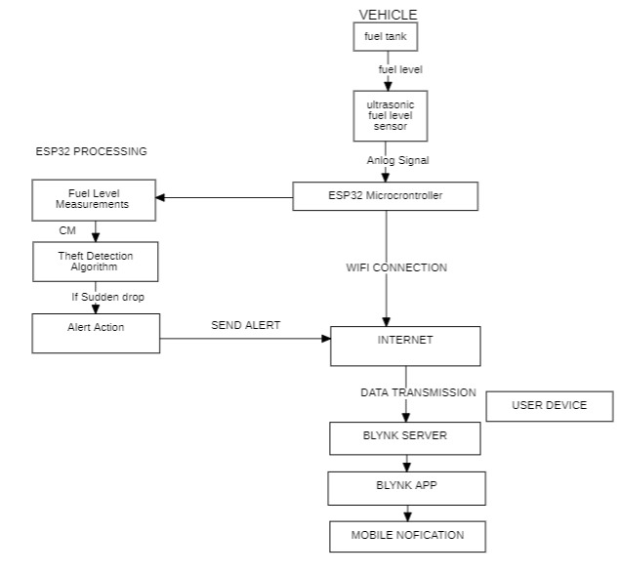

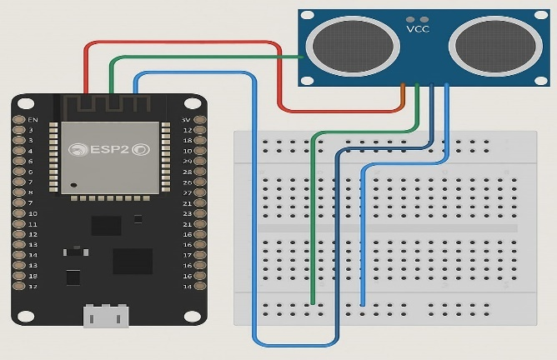

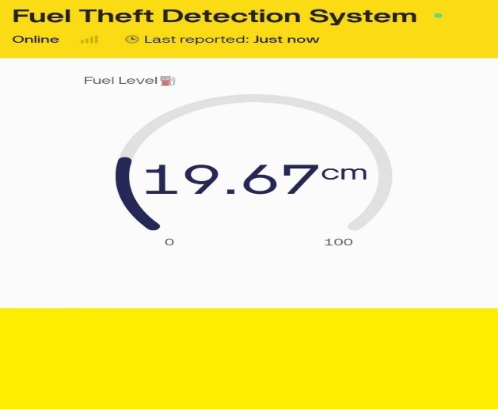

RESULT AND DISCUSSION

The prototype system could also immediately recognize drops in fuel levels and service as an alarm for thefts. Both alerts were sent almost instantly after the event, and while stationary, the ultrasonic sensor was able to consistently register the presence of fuel. Some small variations in reading while going due to the sloshing of the fuel, but the stationary theft detection had a good performance from the system.

CONCLUSION

This simple fuel theft detection system based on ESP32 can act as a low-cost "Real time" solution for monitoring fuel levels and fuel tank unauthorized access. This is an excellent solution for several mobile or remote fuel tanks due to its great wireless functionality and built in sensors. While there is no perfect solution to securing moving fuel, this system provides an additional level of security that can be beneficial in a number of scenarios.